CREATIVE EDUCATIONAL SERVICES
END OF TERM I EXAMINATIONS
ENGLISH
2024
NAME: ____________________________________________ BABY CLASS

1. Read these letter sounds.
a b c d e f g

2. Copy these letter sounds.
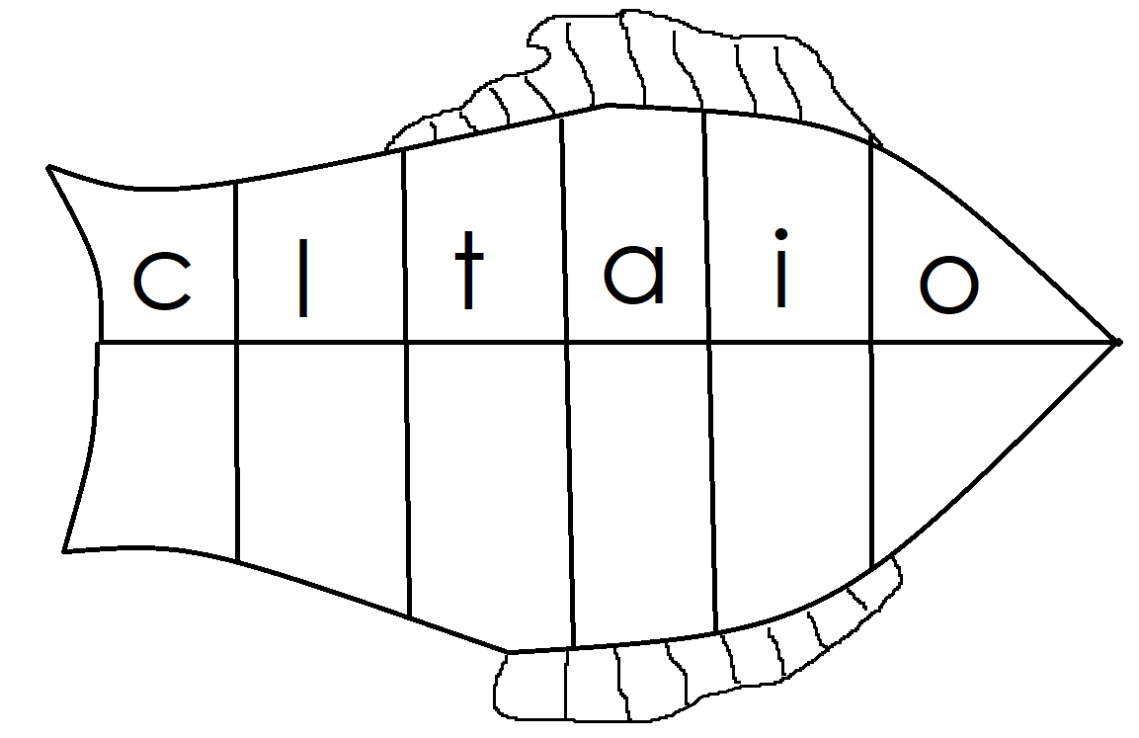
3. Match the same.
a e
b d
c a
d c
e b
4. Copy and draw
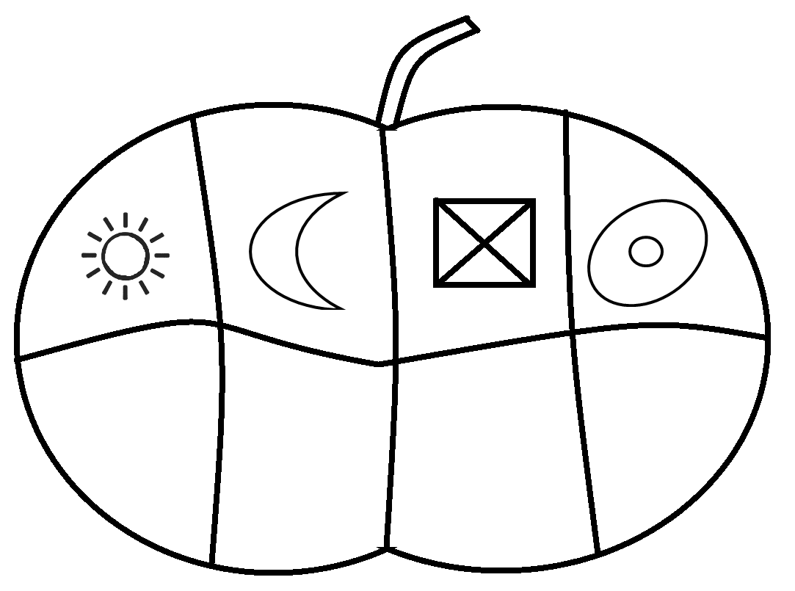

5. Circle the different picture.

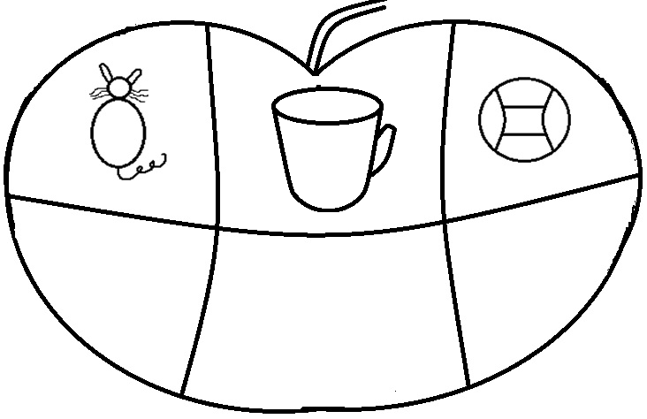

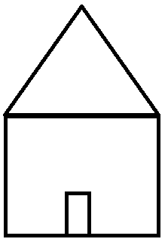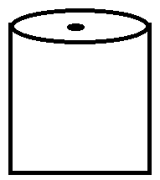
6. Match pictures to words.

tin
cat
 sun
cup

7. Name these pictures.

_____________  _____________
_____________ _____________
_____________ _____________
8. Colour me up.

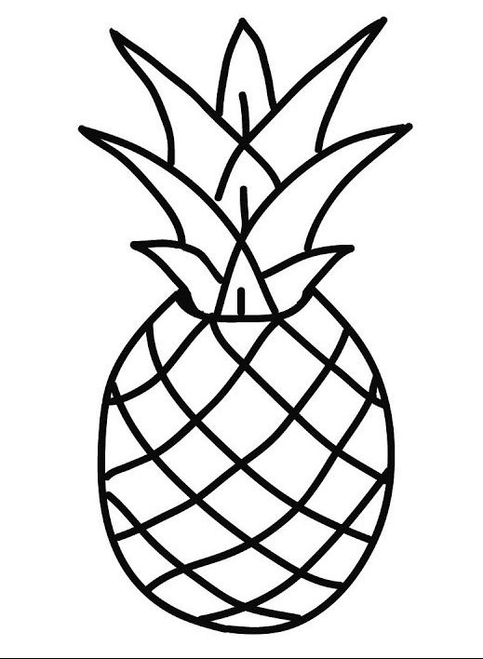

End
Good luck

